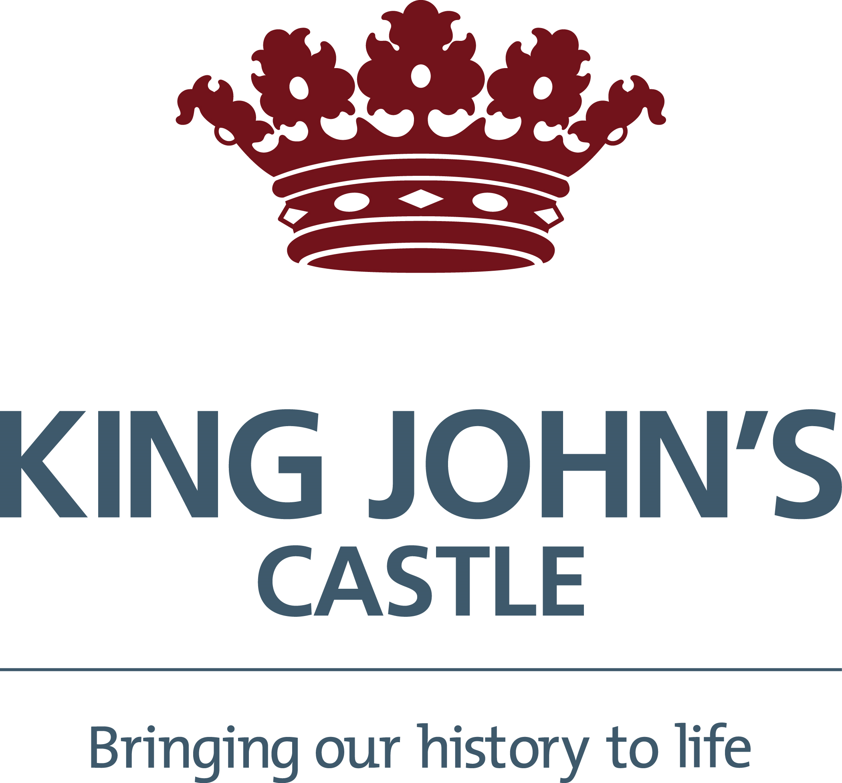
Please email completed form to sales@kingjohnscastle.ie
Name of School
Address
Phone Number
Contact email
Group/School Name (only applicable if booking through agency)
Group Leader Name
Group Leader Email
Group Leader Phone Number
Please tick this box to receive the latest news and offers from our education team.

Date of Visit | 1st Choice date | 2nd Choice date | 3rd Choice date
Number of Pupils |  | Year group of Pupils
Do you have any pupils that require 1:1 support |  | If yes how many?
Please provide details of their requirements (learning/behaviour, physical – no names required)
Total number of adults including 1:1 support adults

Section A –I want my group to do a self-led visit without a guide
Name of attraction |  | Time of arrival
Name of attraction (site 2) |  | Time of arrival
Section B – I want a guided/activity tour
Name of attraction |  | Preferred time
Name of attraction (visit 2) |  | Preferred time

PLEASE READ THE BOOKING TERMS AND CONDITIONS SET OUT HEREUNDER BEFORE SIGNING THE BOOKING FORM.
1. CONTRACT
1.1 Once the Company confirms your booking a Contract is made Discover Limerick DAC (hereinafter called “the Company”) and the School (each a “Party” and together the “Parties”) upon the terms and conditions set out herein (the “Contract”).
1.2 The Company will only confirm a booking once full payment has been received by the Company. No contract between the School and the Company shall come into existence until the Company accepts full payment and issues a confirmation invoice.
1.3 The Company accepts no responsibility for incorrect email or inability to deliver email. If the confirmation of the booking does not arrive on time or at all, then the School must inform the Company and ask the Company to resend the booking confirmation.
1.4 The person who makes the booking accepts these conditions set out herein on behalf of the School and is responsible for all payment due from the School.
1.5 By making the booking the School confirms that they have received the permission from the child’s parent or guardian to attend the tour when a child is under 18 years old.

2. BOOKING AND PAYMENT
2.1 It is the responsibility of the School to check the confirmation invoice carefully and inform the Company in the event of any errors in advance of the tour.
2.2 The School must make full payment to the Company at the time of booking the tour.

3. ALTERATIONS OR CANCELLATION OF BOOKINGS
3.1 The School has 42 calendar days prior to the Tour date to amend or cancel a booking (the “Amendment Deadline”). All amendments or cancellations must be set out in writing to the Company.
3.2 If the School informs the Company of a cancellation after the Amendment Deadline the School will still be charged for the tour and the School will not be refunded for any payment that has been made.
3.3 If the School needs to add extra students or supervising adults or reduce the number of students or supervising adults to the tour these amendments need to be communicated to the Company in writing before the Amendment Deadline. The School may be charged the general group admission rate for any additions to the tour size made after the Amendment Deadline.
3.4 The Company will not give any refunds for cancellations after the Amendment Deadline or if the School fails to arrive on the tour date.

4. FORCE MAJEURE
4.1 Neither party will be liable to the other party for failure to fulfil their obligations under this Contract as a result of any circumstances outside its reasonable control including, without limitation the generality of the foregoing an Act of God, flood, fire, accident, explosion, war, civil commotion, strike or other industrial action, or any act of a third party government or quasi-government organisation.

5. CHANGES BY THE COMPANY
5.1 The Company will make every effort to operate all tours as advertised but the Company reserves the right to alter the typical itinerary of the tour at any time and at the Company’s discretion. The Company will endeavour to avoid this and if this is necessary, the Company will substitute alternative arrangements of comparable monetary value.
5.2 Every effort is made to ensure the accuracy of the Company’s brochures and other printed material at time of going to print, however the Company cannot be held responsible for printing and typographical errors, or changes in the itinerary arising from unforeseen circumstances after the material has gone to print.

6. THE SCHOOL’S OBLIGATIONS AND RESPONSIBILITIES
6.1 Supervising adults must remain with the tour group and supervise students at all times for the duration of the tour.
6.2 The School is responsible for ensuring that all supervising adults in the tour group are aware of the supervision requirements.
6.3 The Company reserves the right to refuse entry to tour groups who do not have enough supervising adults present for the number of students, with no possibility of a refund.
6.4 If the School arrives late on the day of the tour they may be refused entry on the tour, with no possibility of a refund.
6.5 The School must inform the Company at the time of booking of any physical or mental condition of any member of the group which may be relevant. The Company reserves the right to decline to provide a tour to any person who in the Company’s opinion would be inconsistent with the special needs of that person.
6.6 It is the responsibility of the School to check the accuracy of the booking confirmation.

7. DATA PROTECTION
The Company is committed to protecting the School’s privacy and information. The information that the Company’s uses is for the purpose of fulfilling the Company’s Contract as an organiser of a tour. It is necessary for the Company to process this information in order to book, deliver the tour and deal with any follow up queries. Information that is provided to the Company will be held on the Company’s computers (and in other ways) for use by the Company for booking information and to fulfil the Company’s duties as tour organiser. Information supplied may be processed by the Company for statistical analysis and/or market research and may in certain instances be disclosed to third parties for the purpose of fraud prevention and/or debt collection. The Company may contact the School or the School’s representative via email, letter or phone with details of the Company’s products and services which may be of interest to the School. On occasion the Company will have to provide personal information to their suppliers and agents in order to enhance the tour service. By entering into this Contract the School agrees to the use and disclosure of information by the Company as described. A copy of any personal information held by the Company can be provided on request. You have the right to have any inaccurate personal information rectified or erased.

8. COMPLAINTS
8.1 If the School or the School’s representative wishes to make a complaint in relation to the tour, they must immediately inform the Company’s representative at the location where when the complaint arises and shall if the Company requires, complete a form setting out the detail of the complaint. The School shall be obliged to notify the Company in writing of any complaint not later than 28 days after the tour date, no complaint received thereafter shall be entertained.

9. ARBITRATION
Any dispute or difference of any kind whatsoever which arises or occurs between any of the parties hereto in relation to anything or matter arising under, out of or in connection with the contract and/or the booking connected to this contract shall be referred to arbitration under the Arbitration Rules of the Charted Institute of Arbitrators. Claims for less than the jurisdiction of the District Court Small Claims Procedure per booking form may be pursued through the District Court Small Claims Procedure. All claims in excess of the jurisdiction of the District Court Small Claims Procedure shall be referred to arbitration.

10. GENERAL
10.1 The booking conditions detailed herein contain the entire contract between you and the Company. No representation, term, warranty or condition can be expressed or implied by reference to any other writing, advertisement or conversation. This Contract may only be varied in writing by a duly authorised officer of the Company.
10.2 This Contract and all matters arising out of it are governed by Irish law. Both parties agree that any dispute, claim or other matter which arises out of or in connection with this Contract will be dealt with by the Courts of the Republic of Ireland only.

